**Web Development**

**Project:**

Movie Booking System

**Submitted by:**

Aditya Garg

III Year

B.Tech.(CSE)

SRM University

**Dated:**

12th June 2019- 2nd July 2019

**Under Guidance of:**

Mr. Santu Purkait

Director

Netcamp Solutions Private Limited

(9331090003)



**Acknowledgement**

I would like to express my special thanks of gratitude to my teacher Mr. Santu Purkait who gave me the golden opportunity to do this wonderful project on this topic which also helped me in doing a lot of Research and I came to know about so many new things I am really thankful to him.

I would also like to express my immense gratitude to Netcamp Solutions Private Limited, for organizing the event that provided me with this golden opportunity.

Lastly I would also like to thank my parents and friends who helped me a lot in finalizing this project within the limited time frame.

-Aditya Garg

III Year

B.Tech.(CSE)

SRM University

**Certificate**

This is to certify that the project report entitled “Online Movie Booking System” being submitted by Aditya Garg, Reg. No. RA1611003030294 of SRM University, Modinagar, Delhi-NCR, is work of collection carried out by him under my supervision for the period of 12th June 2019- 2nd July 2019.

In my opinion the project report has fulfilled the requirement according to the guidance and standard necessary for submission.

Mr. Santu Purkait

Director

Netcamp Solutions Private Limited

**Project File Structure**

* bootstrap
* bootstrap.min.css
* bootstrap.min.js
* css
* main.css
* img
* banner.jpg
* show.png
* includes
* foot.php
* head.php
* nav.php
* js
* jquery-2.2.3.min.js
* admovies.php
* about.php
* alluser.php
* aduser.php
* adwel.php
* chmov.php
* conf.php
* confuser.php
* index.php
* log.php
* log.txt
* login.php
* logout.php
* movies.php
* seatsel.php
* signup.php
* signupform.html
* style.css
* update.php
* user.php
* welcome.php

**Index.php**

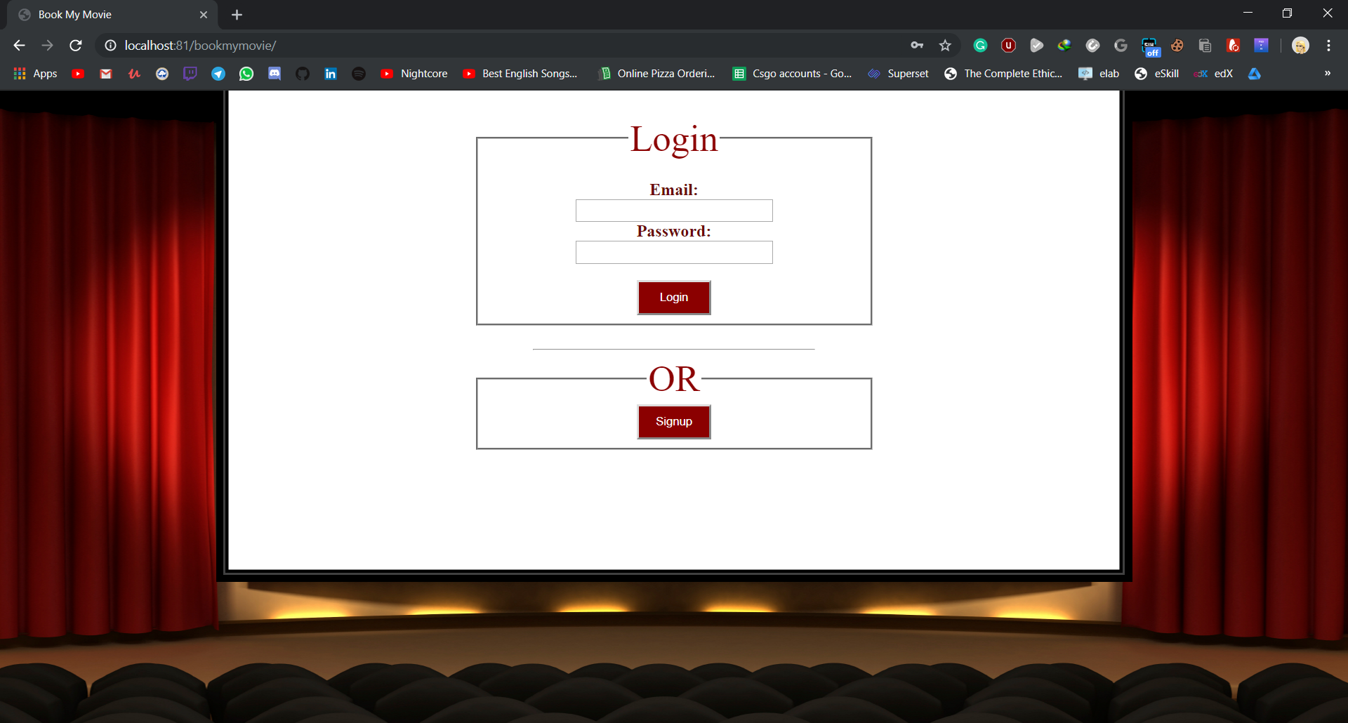

<?php

session_start();

if(isset($_SESSION['name'])){

header('location:welcome.php');

}else{

?>

<!doctype html>

<html>

<head>

<title>Book My Movie</title>

<link href="style.css" rel="stylesheet">

<script type="text/javascript" src="script.js"></script>

</head>

<body>

<div class="loginform">

<form method="POST" action="login.php">

<fieldset>

<legend>Login</legend>

<br><label>Email:</label><br>

<input type="email" name="a" size="30" required><br>

<label>Password:</label><br>

<input type="password" name="b" size="30" required><br><br>

<input type="submit" class="button" value="Login"><br>

</fieldset>

</form>

<br>

<hr>

<form>

<fieldset>

<legend>OR</legend>

<button value="Signup" class="button" ><a href="signupform.html">Signup</a></button><br>

</fieldset>

</form>

</div>

<script src="js/jquery-2.1.4.js"></script>

<script src="bootstrap/bootstrap.min.js"></script>

</body>

</html>

<?php

}

?>

**Login.php**

<!doctype html>

<html>

<head>

<title>Book My Movie</title>

<link href="style.css" rel="stylesheet">

</head>

<body>

<center>

<?php

session_start();

function getUserIpAddr(){

if(!empty($_SERVER['HTTP_CLIENT_IP'])){

$ip = $_SERVER['HTTP_CLIENT_IP'];

}elseif(!empty($_SERVER['HTTP_X_FORWARDED_FOR'])){

$ip = $_SERVER['HTTP_X_FORWARDED_FOR'];

}else{

$ip = $_SERVER['REMOTE_ADDR'];

}

return $ip;

}

$log= fopen('log.txt','a');

date_default_timezone_set('Asia/Kolkata');

$n= $_POST['a'];

$p= $_POST['b'];

mysql_connect("localhost","root","");

mysql_select_db("bookmymovie");

$q="SELECT * FROM admin WHERE password='$p' AND email='$n'";

$res=mysql_query($q);

$row= mysql_num_rows($res);

if($row!=0){

$_SESSION['name']=$n;

header("location:adwel.php");

$_SESSION['email']="admin";

$_SESSION['ip']=getUserIpAddr();

$t= "admin logged in from ".getUserIpAddr().

' at '.date('Y/m/d').' '.date('H:i:s').PHP_EOL;

fwrite($log, $t);

fclose($log);

}

else{

$query="SELECT * FROM users WHERE password='$p' AND email='$n'";

$res=mysql_query($query);

$row= mysql_fetch_array($res);

if($row!=0){

if($row[3]!=1){

header( "refresh:3;url=index.php" );

echo "<h2>Account not yet confirmed</h2>";

echo "<h6>Redirecting in 5 seconds...</h6>";

}

else{

$_SESSION['name']=$row[0];

$_SESSION['email']= $row[1];

$_SESSION['password']= $row[2];

$_SESSION['phone']= $row[4];

$_SESSION['ip']=getUserIpAddr();

header("location:welcome.php");

$t= "user:".$_SESSION['email'].' logged in from '.$_SESSION['ip'].

' at '.date('Y/m/d').' '.date('H:i:s').PHP_EOL;

fwrite($log, $t);

fclose($log);

}

}

else{

header( "refresh:3;url=index.php" );

echo "<h2>Invalid email or password</h2>";

echo "<h6>Redirecting in 3 seconds...</h6>";

}

}

?>

</center>

</body>

</html>

**Sighupform.html**

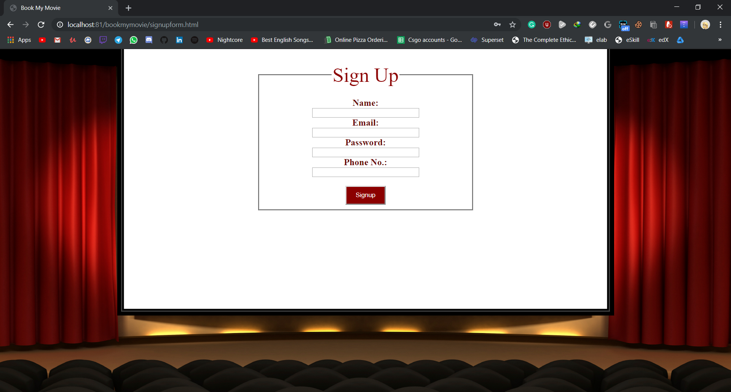

<html>

<head>

<title>Book My Movie</title>

<link href="style.css" rel="stylesheet">

<script type="text/javascript" src="script.js"></script>

</head>

<body>

<div class="loginform" id="su">

<form method="POST" action="signup.php">

<fieldset>

<legend>Sign Up</legend>

<br><label>Name:</label><br>

<input type="text" name="a" size="30" required><br>

<label>Email:</label><br>

<input type="email" name="b" size="30" required><br>

<label>Password:</label><br>

<input type="password" id="pass" name="c" size="30" required><br>

<label>Phone No.:</label><br>

<input type="tel" name="d" size="30" required><br><br>

<input type="submit" class="button" value="Signup"><br>

</fieldset>

</form>

</div>

<script src="js/jquery-2.1.4.js"></script>

<script src="bootstrap/bootstrap.min.js"></script>

</body>

</html>

**Signup.php**

<!doctype html>

<html>

<head>

<title>Book My Movie</title>

<link href="style.css" rel="stylesheet">

</head>

<body>

<?php

echo "<center>";

function getUserIpAddr(){

if(!empty($_SERVER['HTTP_CLIENT_IP'])){

$ip = $_SERVER['HTTP_CLIENT_IP'];

}elseif(!empty($_SERVER['HTTP_X_FORWARDED_FOR'])){

$ip = $_SERVER['HTTP_X_FORWARDED_FOR'];

}else{

$ip = $_SERVER['REMOTE_ADDR'];

}

return $ip;

}

$log= fopen('log.txt','a');

date_default_timezone_set('Asia/Kolkata');

$n= $_POST['a'];

$e= $_POST['b'];

$p= $_POST['c'];

$c= 0;

$m= $_POST['d'];

mysql_connect("localhost","root","");

mysql_select_db("bookmymovie");

$query="SELECT * from users where name='$n' AND email='$e'";

$res=mysql_query($query);

$row= mysql_num_rows($res);

if($row==0){

$query="INSERT INTO users VALUES ('$n', '$e','$p', '$c','$m')";

mysql_query($query);

mysql_query("DELETE FROM users where email=' '");

header( "refresh:5;url=index.php" );

echo '<h2>Signed Up Successfully</h2>';

echo '<h4>Your Account will be Confirmed in a few Hours</h4>';

echo "<h6>Redirecting in 5 seconds...</h6>";

$t= "user: ".$e.' created (unconfirmed), from '.getUserIpAddr().

' at '.date('Y/m/d').' '.date('H:i:s').PHP_EOL;

fwrite($log, $t);

fclose($log);

}

else{

header( "refresh:5;url=signupform.html" );

echo '<h2>User Already Exists</h2>';

echo "<h6>Redirecting in 5 seconds...</h6>";

}

echo "</center>";

?>

</body>

</html>

**Welcome.php**

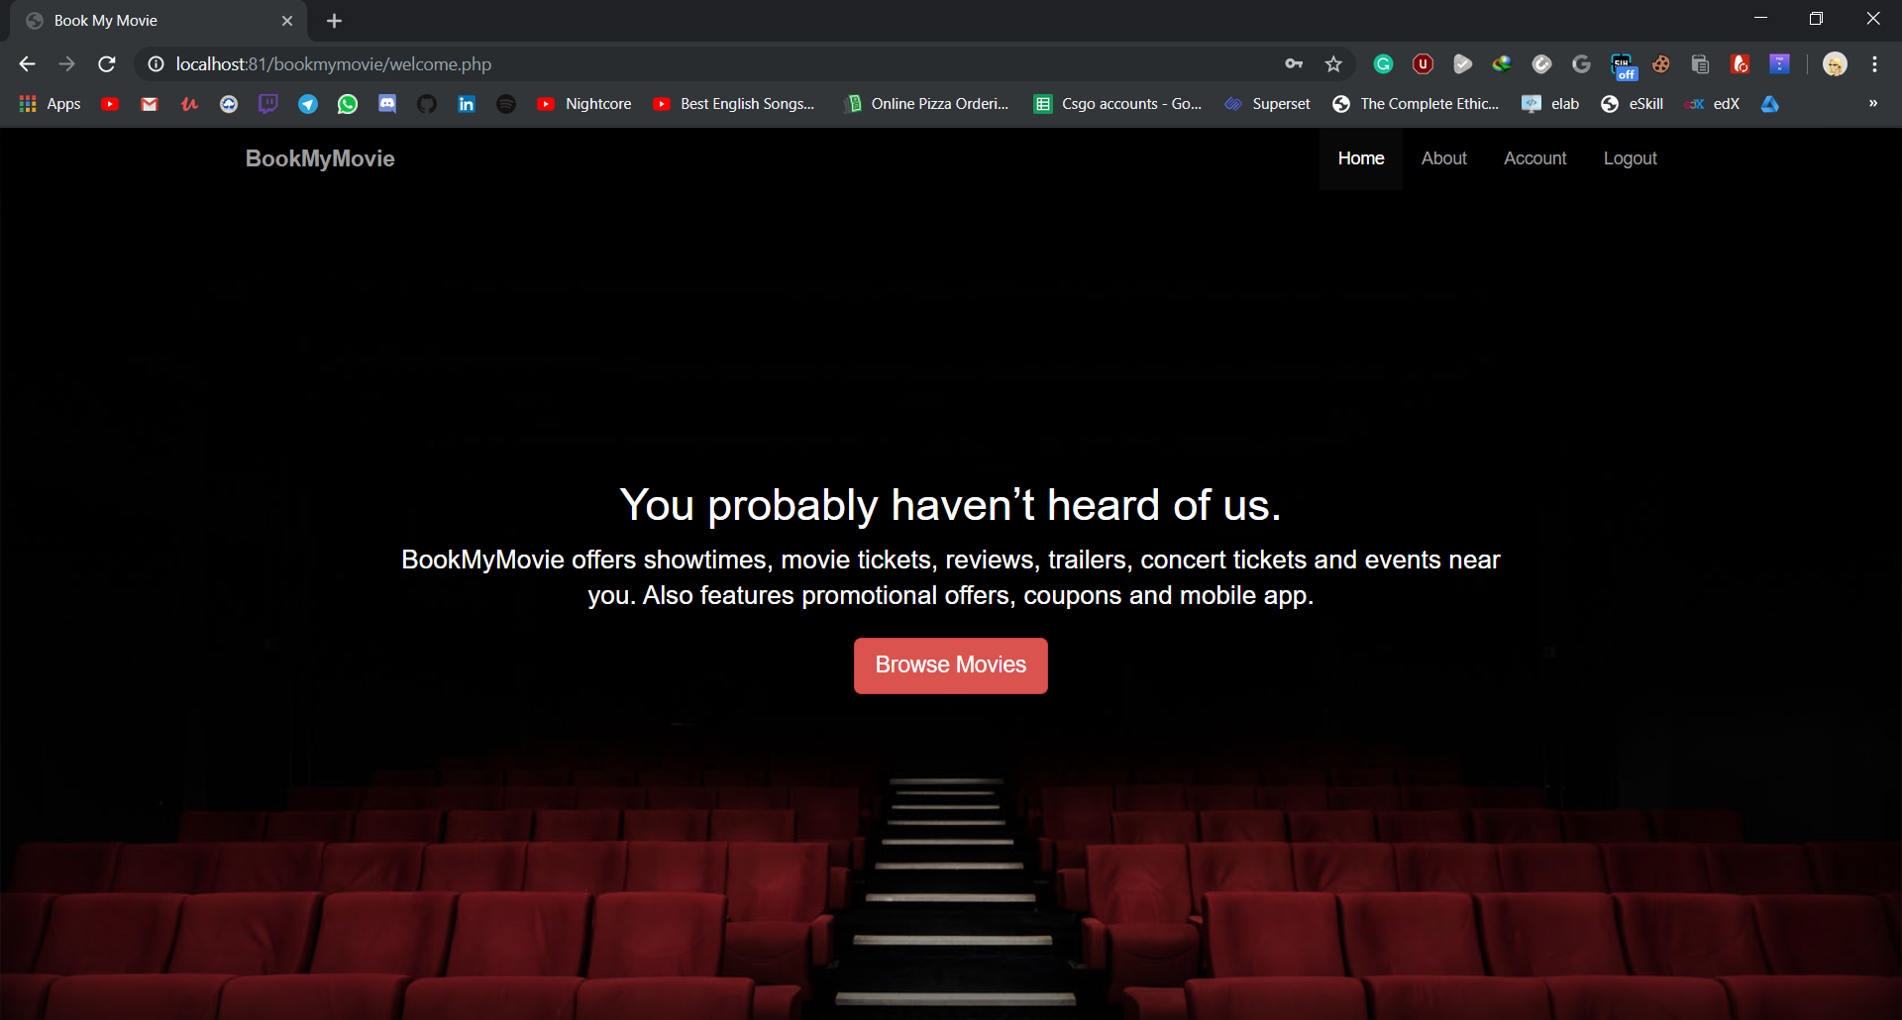

<?php

session_start();

if(isset($_SESSION['name']) && $_SESSION['name']=='admin@gg'){

header('location:adwel.php');

}

else if(isset($_SESSION['name'])){

include('includes/head.php');

include('includes/nav.php');

?>

<div class='cover'>

<div class="cover-text">

<h1>You probably haven&rsquo;t heard of us.</h1>

<p class="lead">BookMyMovie offers showtimes, movie tickets, reviews, trailers, concert tickets and events near you. Also features promotional offers, coupons and mobile app.</p>

<a href="movies.php" role="button" class="btn btn-danger btn-lg">Browse Movies</a>

</div>

</div>

<?php

}

else{

header("location:index.php");

}

include('includes/foot.php')

?>

**About.php**

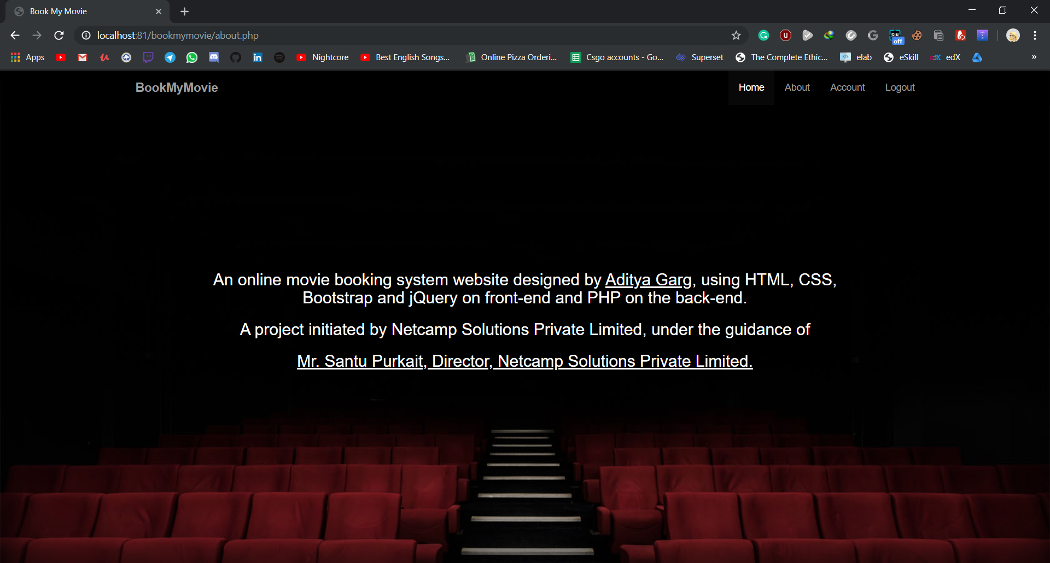

<?php

session_start();

include('includes/head.php');

if(isset($_SESSION['name'])){

include('includes/nav.php');

?>

<div class="cover">

<div class="cover-text">

<h3>An online movie booking system website designed by <u>Aditya Garg,</u> using HTML, CSS, Bootstrap and jQuery

on front-end and PHP on the back-end.</h3>

<h3>A project initiated by Netcamp Solutions Private Limited, under the guidance of</h3>

<h3><u>Mr. Santu Purkait, Director, Netcamp Solutions Private Limited.</u>

</h3>

</div>

</div>

<?php

}

else{

header("location:index.html");

}

include('includes/foot.php')

?>

**User.php**

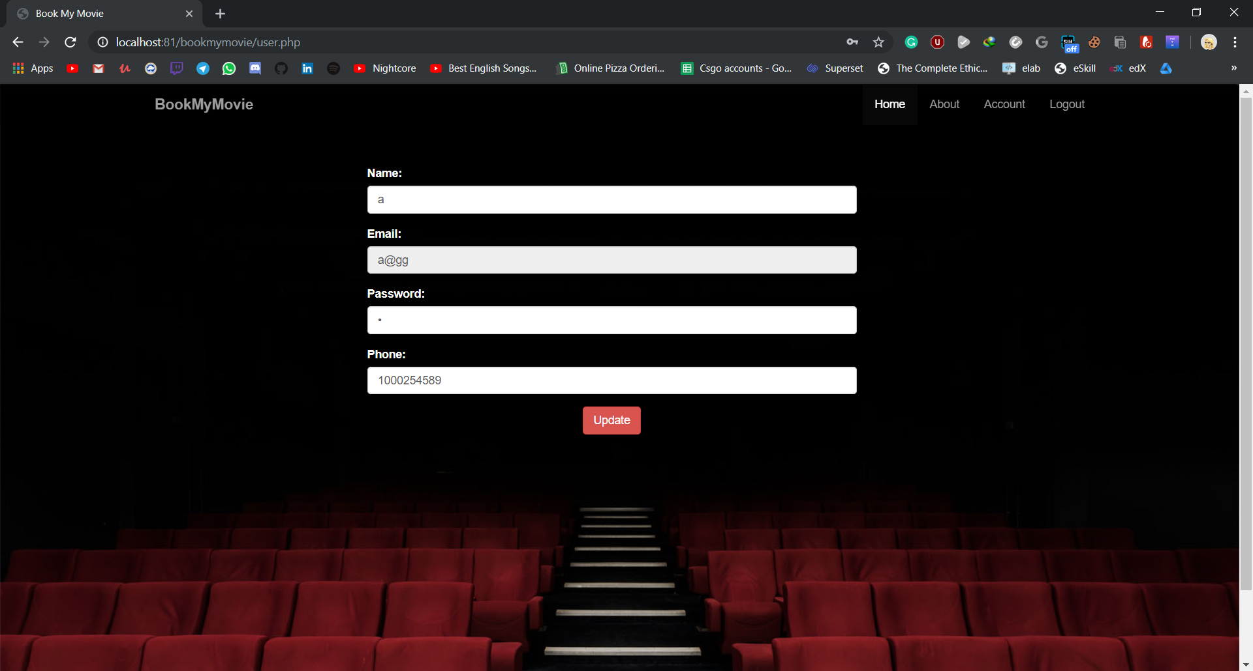

<?php

session_start();

include('includes/head.php');

if(isset($_SESSION['name'])){

include('includes/nav.php');

$n=$_SESSION['name'];

$e=$_SESSION['email'];

$p=$_SESSION['password'];

$m=$_SESSION['phone'];

?>

<form method="post" action="update.php" id="up">

<div class="form-group">

<label for="name">Name:</label>

<input id="name" class="form-control" value="<?php echo "$n";?>" type="text" name="a">

</div>

<div class="form-group">

<label for="email">Email:</label>

<input id="email" class="form-control" value="<?php echo "$e";?>" type="email" name="b" disabled>

</div>

<div class="form-group">

<label for="password">Password:</label>

<input id="password" class="form-control" value="<?php echo "$p";?>" type="password" name="c">

</div>

<div class="form-group">

<label for="phone">Phone:</label>

<input id="phone" class="form-control" value="<?php echo "$m";?>" type="tel" name="d">

</div>

<div class="form-actions">

<button class="btn btn-danger" id="upd" type="submit">Update</button>

</div>

</form>

<?php

}

include('includes/foot.php');

?>

**Update.php**

<?php

session_start();

$a=$_POST['a'];

$b=$_POST['b'];

$c=$_POST['c'];

$d=$_POST['d'];

$n=$_SESSION['name'];

$e=$_SESSION['email'];

$p=$_SESSION['password'];

$m=$_SESSION['phone'];

include('includes/head.php');

mysql_connect("localhost","root","");

mysql_select_db("bookmymovie");

$qu="UPDATE users SET phone='$d', name='$a', password='$c' WHERE email='$e'";

mysql_query($qu);

$t= "user: ".$e.' updated info, from '.$_SESSION['ip'].

' at '.date('Y/m/d').' '.date('H:i:s').PHP_EOL;

include('includes/foot.php');

header('location:logout.php');

?>

**Movies.php**

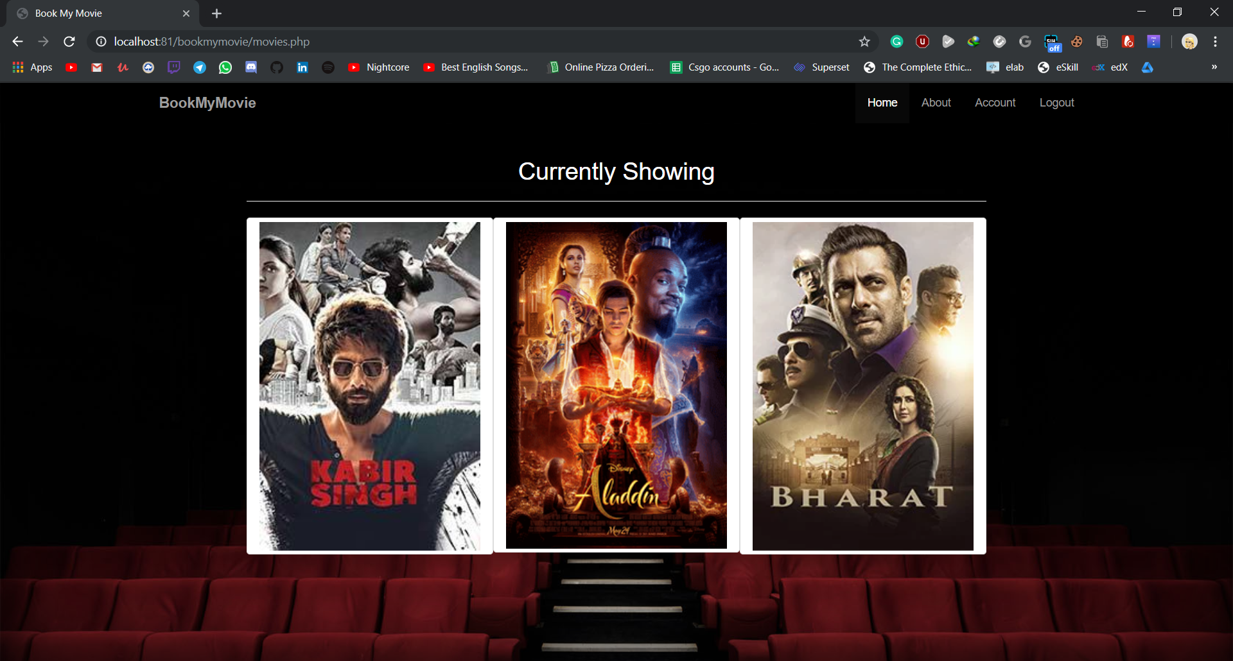

<?php

session_start();

include('includes/head.php');

if(isset($_SESSION['name'])){

include('includes/nav.php');

mysql_connect("localhost","root","");

mysql_select_db("bookmymovie");

?>

<div class="container cover" id="movielist">

<h2>Currently Showing</h2><hr>

<?php

$q="SELECT * FROM movie";

$result=mysql_query($q);

while($row=mysql_fetch_array($result)){

$x=$row[3];

echo"<a href='seatsel.php?value=$row[0]'><img class='col-lg-4 img-thumbnail' src='$x'></a>";

}

?>

</div>

<?php

}else

header("location:index.html");

include('includes/foot.php');

?>

**Seatsel.php**

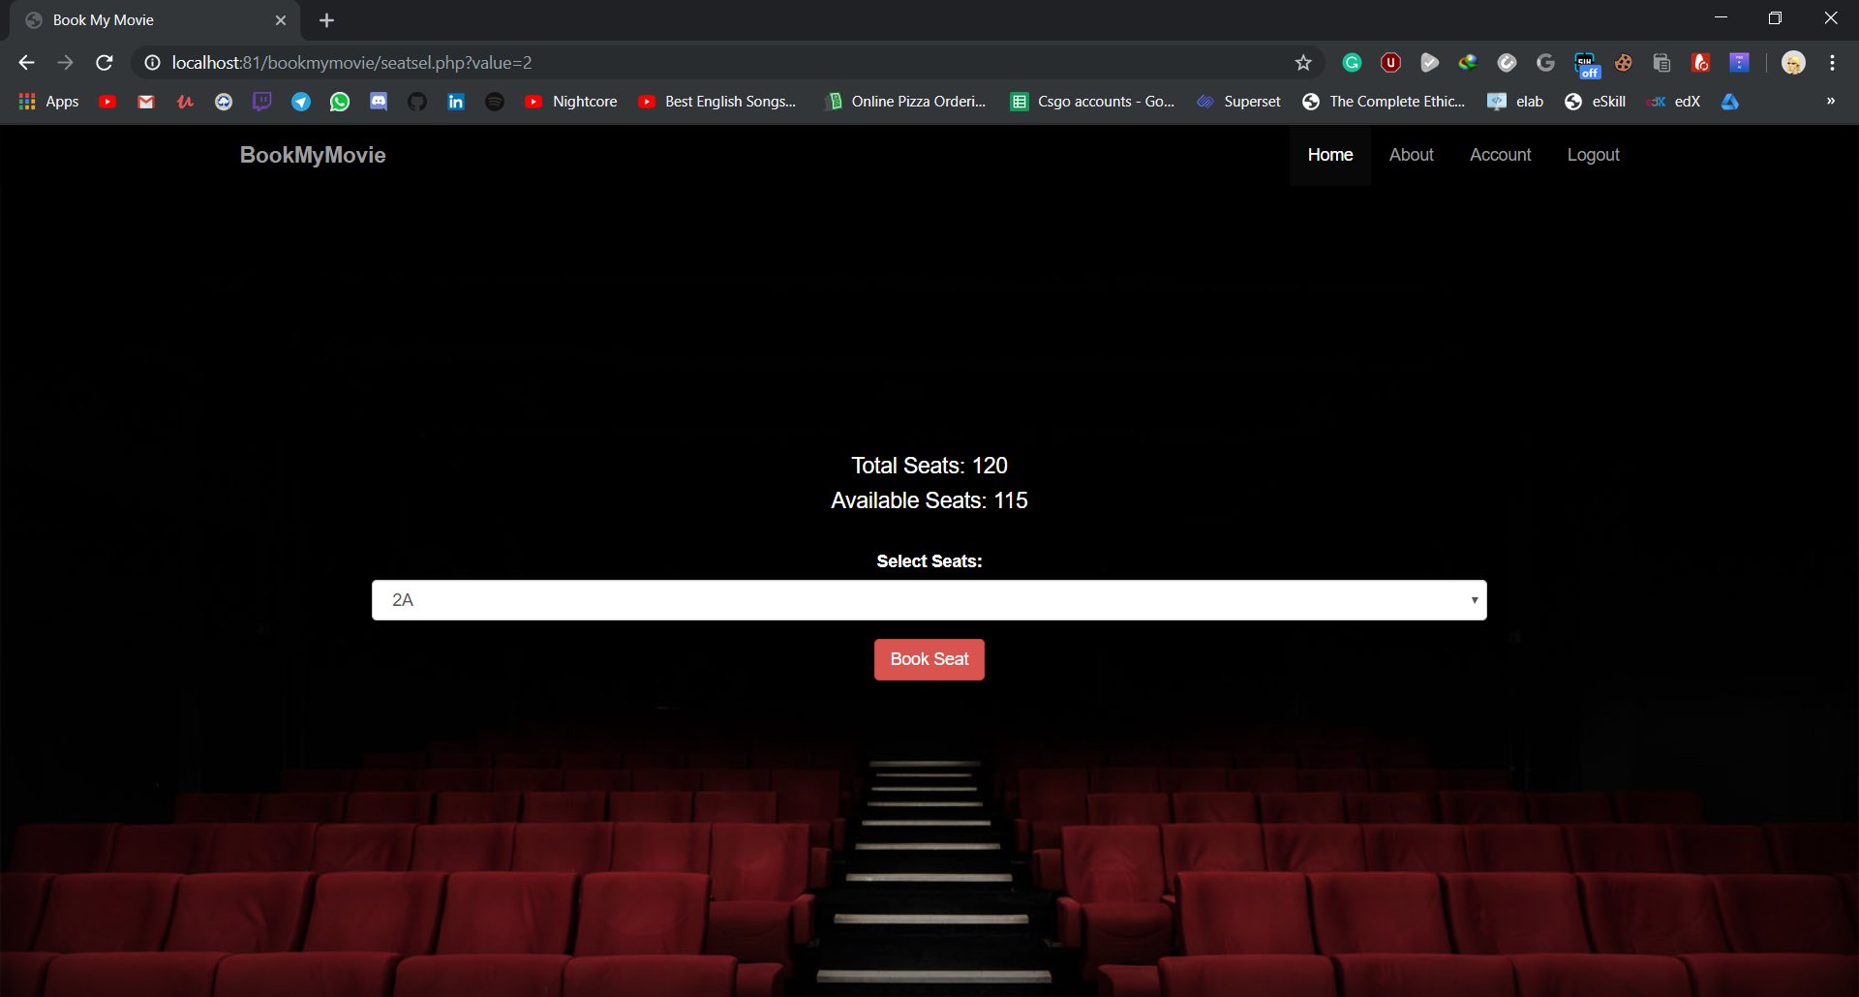

<?php

session_start();

include('includes/head.php');

include('includes/nav.php');

if(isset($_GET['value']) && isset($_SESSION['name']) && $_SESSION['name']!='admin@gg'){

$m = $_GET['value'];

$_SESSION['mov']=$m;

mysql_connect('localhost','root','');

mysql_select_db('bookmymovie');

if($m==1)

$qu="SELECT * FROM s1";

else if($m==2)

$qu="SELECT * FROM s2";

else

$qu="SELECT * FROM s3";

$query="SELECT * FROM movie WHERE sr='$m'";

$res= mysql_query($query);

$res2=mysql_query($qu);

$row2=mysql_num_rows($res2);

$row=mysql_fetch_array($res);

$avail=$row[5]-$row2;

$th=array(

array('1A','2A','3A','4A','5A','6A','7A','8A','9A','10A','11A','12A'),

array('1B','2B','3B','4B','5B','6B','7B','8B','9B','10B','11B','12B'),

array('1C','2C','3C','4C','5C','6C','7C','8C','9C','10C','11C','12C'),

array('1D','2D','3D','4D','5D','6D','7D','8D','9D','10D','11D','12D'),

array('1E','2E','3E','4E','5E','6E','7E','8E','9E','10E','11E','12E'),

array('1F','2F','3F','4F','5F','6F','7F','8F','9F','10F','11F','12F'),

array('1G','2G','3G','4G','5G','6G','7G','8G','9G','10G','11G','12G'),

array('1H','2H','3H','4H','5H','6H','7H','8H','9H','10H','11H','12H'),

array('1I','2I','3I','4I','5I','6I','7I','8I','9I','10I','11I','12I'),

array('1J','2J','3J','4J','5J','6J','7J','8J','9J','10J','11J','12J')

);

?>

<div class="cover">

<div class="cover-text">

<h4>Total Seats: 120</h4>

<h4>Available Seats: <?php echo "$avail";?></h4><br>

<form method="post" action="conf.php">

<div class="form-group">

<label for="sr">Select Seats:</label>

<select id="sr" class="form-control" type="text" name="a">

<?php

foreach($th as $r){

foreach($r as $c){

if($m==1)

$qu="SELECT * from s1 where s='$c'";

else if($m==2)

$qu="SELECT * from s2 where s='$c'";

else

$qu="SELECT * from s3 where s='$c'";

$res= mysql_query($qu);

$row=mysql_num_rows($res);

if($row==0)

echo "<option>$c</option>";

}}

?>

</select>

</div>

<?php

echo '<button class="btn btn-danger" name="c" type="submit">Book Seat</button>';

?>

</form>

</div>

</div>

<?php

}

else{

header("location:index.php");

}

include('includes/foot.php')

?>

**Conf.php**

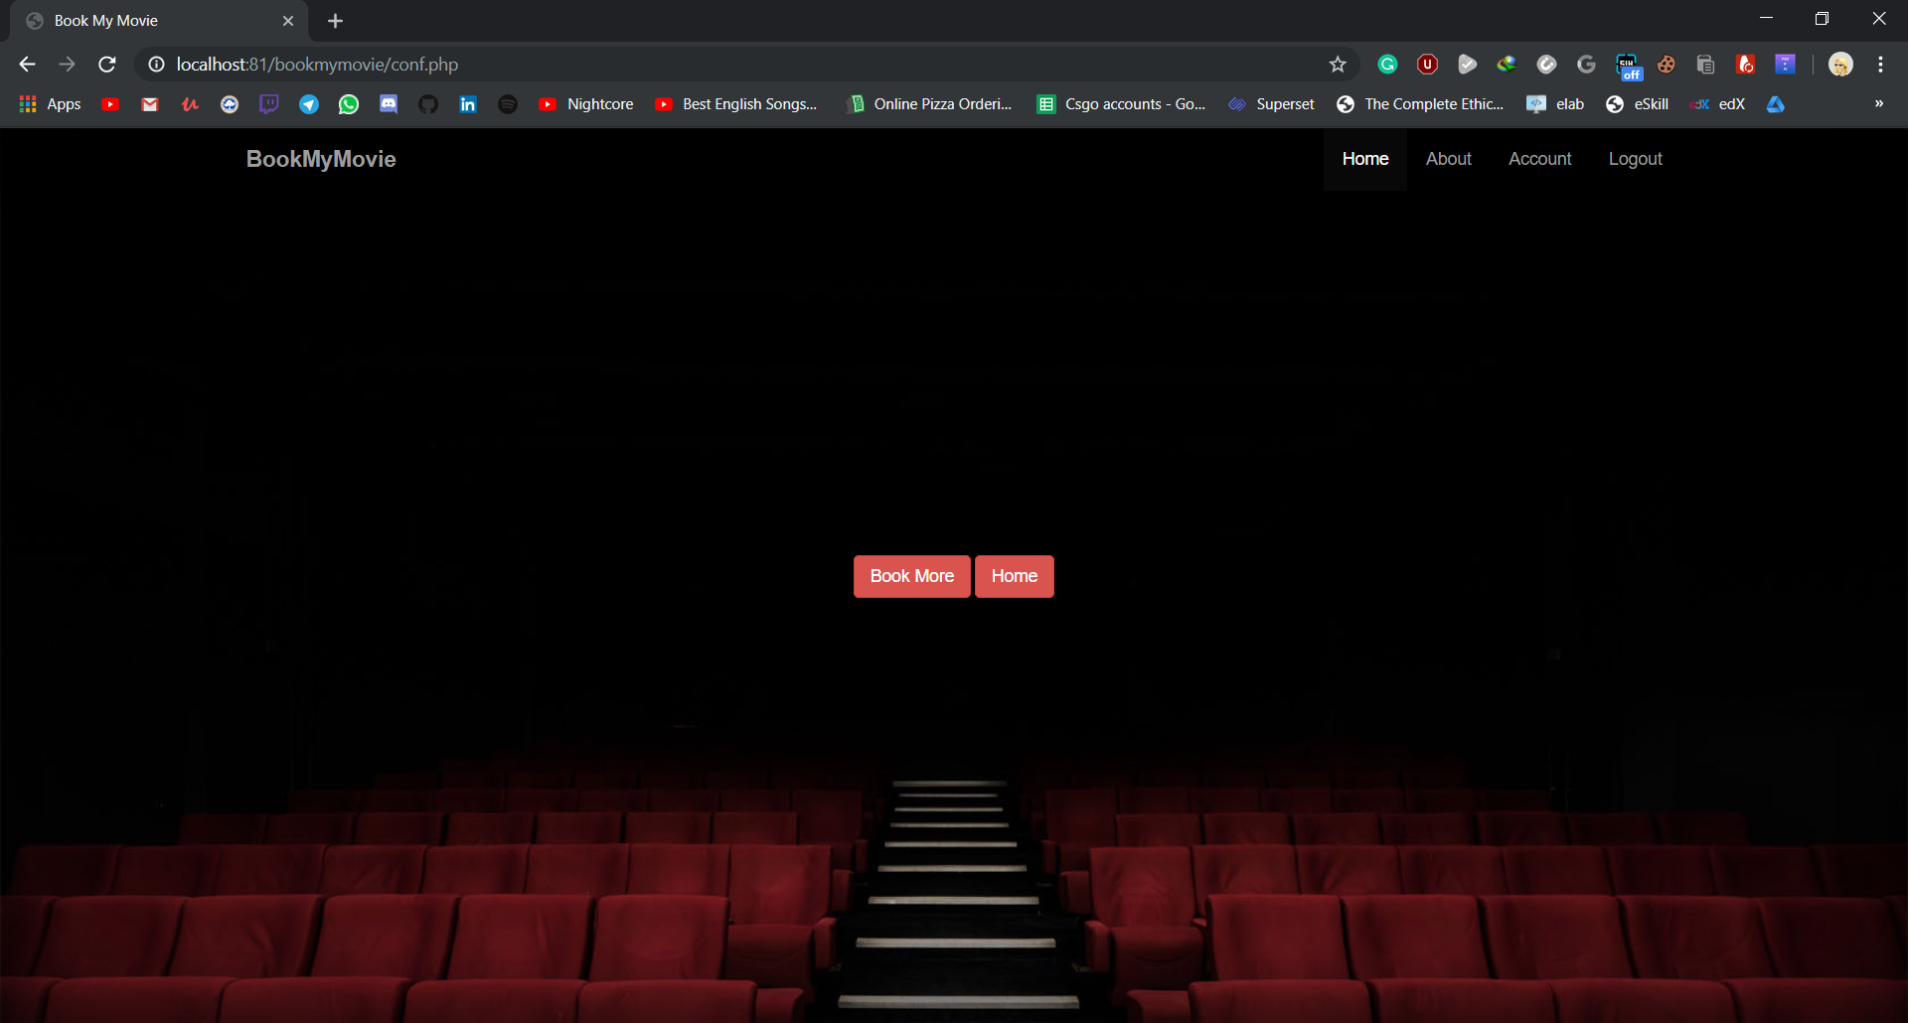

<?php

session_start();

include('includes/head.php');

include('includes/nav.php');

if(isset($_SESSION['name']) && $_SESSION['name']!='admin@gg' && isset($_SESSION['mov'])){

$m=$_SESSION['mov'];

$s= $_POST['a'];

mysql_connect('localhost','root','');

mysql_select_db('bookmymovie');

if($m==1)

$qu="INSERT INTO s1 VALUES('$s');";

else if($m==2)

$qu="INSERT INTO s2 VALUES('$s')";

else

$qu="INSERT INTO s3 VALUES('$s')";

mysql_query($qu);

mysql_query("DELETE FROM s1 where s=' '");

mysql_query("DELETE FROM s2 where s=' '");

mysql_query("DELETE FROM s3 where s=' '");

$qu="SELECT * from movie where sr=$m";

$res=mysql_query($qu);

$row=mysql_fetch_array($res);

$t= "user: ".$_SESSION['email'].' booked seat '.$s.' for '.$row[1].', from '.$_SESSION['ip'].

' at '.date('Y/m/d').' '.date('H:i:s').PHP_EOL;

?>

<div class="cover">

<div class="cover-text">

<a href="movies.php" class="btn btn-danger">Book More</a>

<a href="index.php" class="btn btn-danger">Home</a>

</div>

</div>

<?php

}

else{

header("location:index.php");

}

include('includes/foot.php')

?>

**Logout.php**

<?php

session_start();

session_unset();

session_destroy();

$log= fopen('log.txt','a');

date_default_timezone_set('Asia/Kolkata');

$t= "user:".$_SESSION['email'].' logged out, from '.$_SESSION['ip'].

' at '.date('Y/m/d').' '.date('H:i:s').PHP_EOL;

fwrite($log, $t);

fclose($log);

header("location:index.php");

?>

**Adwel.php**

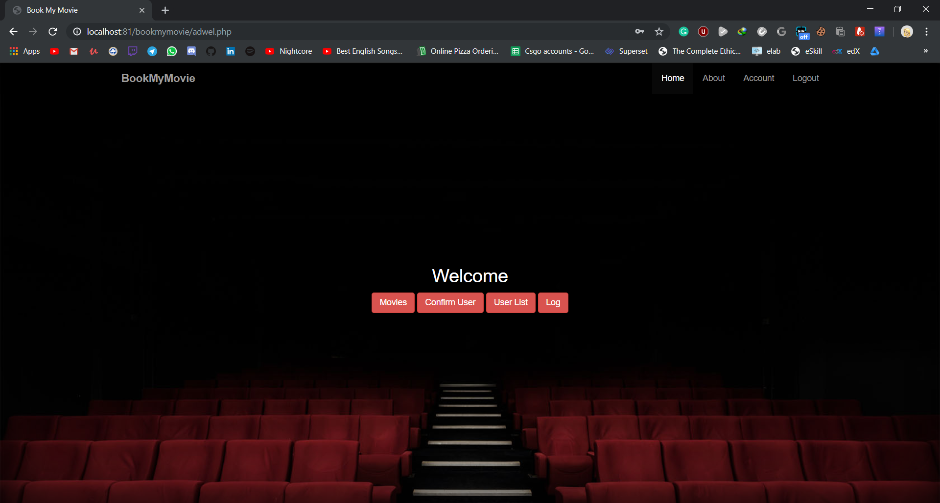

<?php

session_start();

if(isset($_SESSION['name']) && $_SESSION['name']=='admin@gg'){

include('includes/head.php');

include('includes/nav.php');

?>

<div class='cover'>

<div class="cover-text">

<h2>Welcome</h2>

<a class="btn btn-danger" href="admovies.php">Movies</a>

<a class="btn btn-danger" href="aduser.php">Confirm User</a>

<a class="btn btn-danger" href="alluser.php">User List</a>

<a class="btn btn-danger" href="log.php">Log</a>

</div>

</div>

<?php

}

else{

header("location:index.php");

}

include('includes/foot.php')

?>

**Admovies.php**

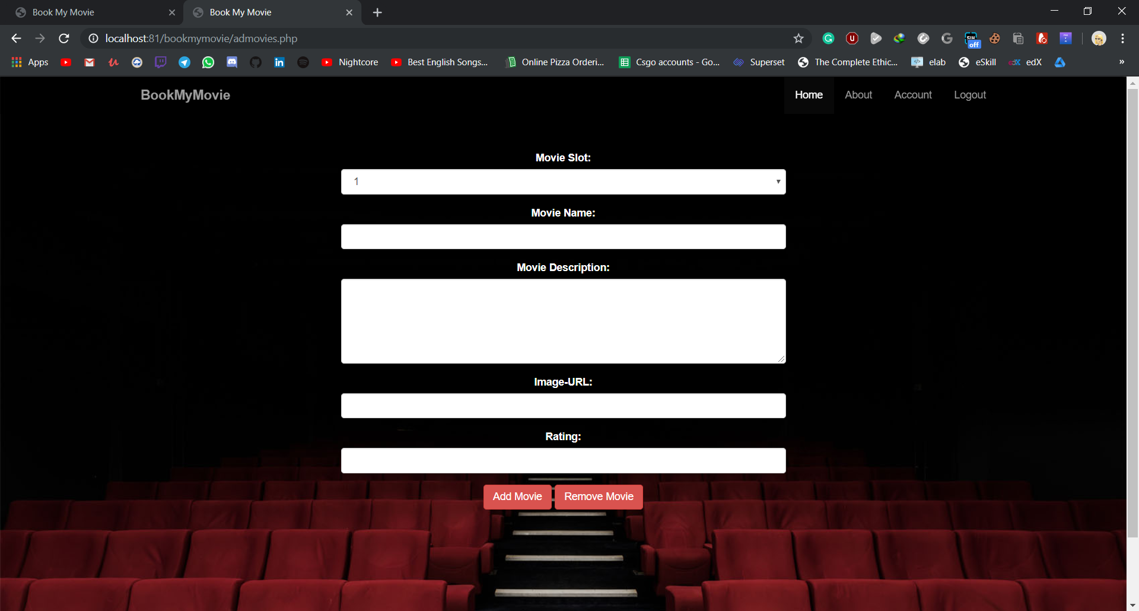

<?php

session_start();

if(isset($_SESSION['name']) && $_SESSION['name']=='admin@gg'){

include('includes/head.php');

include('includes/nav.php');

mysql_connect("localhost","root","");

mysql_select_db("bookmymovie");

echo"<center>";

?>

<form method="post" action="chmov.php" id="up2">

<div class="form-group">

<label for="sr">Movie Slot:</label>

<select id="sr" class="form-control" type="text" name="a">

<option>1</option>

<option>2</option>

<option>3</option>

</select>

</div>

<div class="form-group">

<label for="mv-name">Movie Name:</label>

<input id="mv-name" class="form-control" type="text" name="b">

</div>

<div class="form-group">

<label for="mv-description">Movie Description:</label>

<textarea class="form-control" rows="5" id="mv-description" name="c"></textarea>

</div>

<div class="form-group">

<label for="mv-img">Image-URL:</label>

<input id="mv-img" class="form-control" type="text" name="d">

</div>

<div class="form-group">

<label for="mv-rationg">Rating:</label>

<input id="mv-rationg" class="form-control" type="number" name="e">

</div>

<button class="btn btn-danger form-actions" type="submit" name="mvbt" value="add">Add Movie</button>

<button class="btn btn-danger form-actions" type="submit" name="mvbt" value="del">Remove Movie</button>

</form>

<?php

}

else if(isset($_SESSION['name'])){

header('location:movies.php');

}

else{

header( "refresh:3;url=index.php" );

echo "<h2>Unauthorized Access</h2>";

echo "<h6>Redirecting in 5 seconds...</h6>";

}

include('includes/foot.php')

?>

**Chmov.php**

<?php

session_start();

include('includes/head.php');

include('includes/nav.php');

$s= $_POST['a'];

$n= $_POST['b'];

$d= $_POST['c'];

$i= $_POST['d'];

$r= $_POST['e'];

$p="";

if(isset($_SESSION['name']) && $_SESSION['name']=='admin@gg'){

mysql_connect("localhost","root","");

mysql_select_db("bookmymovie");

if($_POST['mvbt']=='add'){

$query="SELECT * FROM movie WHERE sr=$s";

$res=mysql_query($query);

$row= mysql_num_rows($res);

if($row==0){

$q="INSERT INTO movie VALUES ($s,'$n','$d','$i','$r', 120)";

}

else{

$q="UPDATE movie SET name='$n', description='$d', image='$i', rating='$r' WHERE sr=$s";

}

}

else if($_POST['mvbt']=='del'){

$q="DELETE FROM movie where sr=$s";

}

mysql_query($q);

echo "db updated";

header('location:welcome.php');

}

else{

header( "refresh:3;url=index.php" );

echo "<h2>Unauthorized Access</h2>";

echo "<h6>Redirecting in 5 seconds...</h6>";

}

include('includes/foot.php');

?>

**Aduser.php**

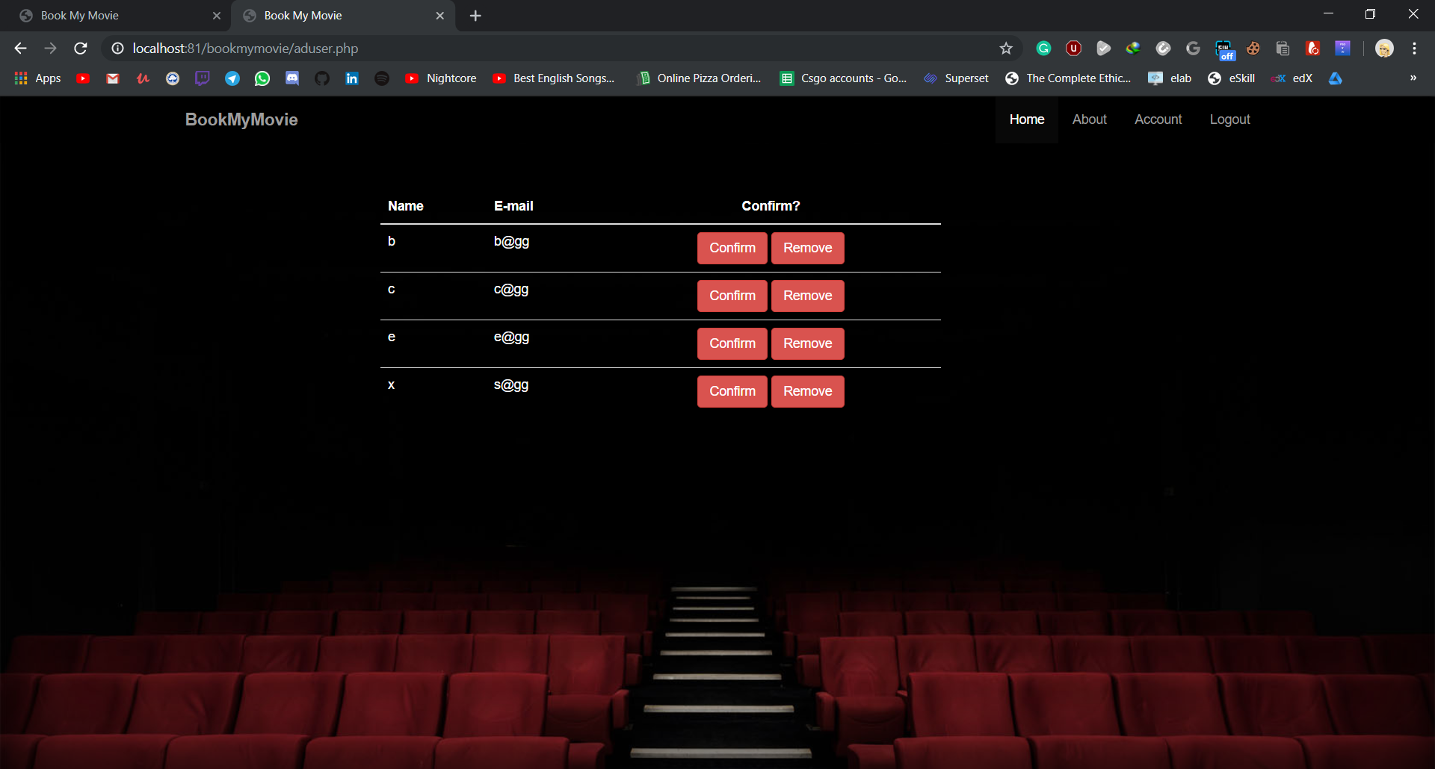

<?php

session_start();

if(isset($_SESSION['name']) && $_SESSION['name']=='admin@gg'){

include('includes/head.php');

include('includes/nav.php');

mysql_connect("localhost","root","");

mysql_select_db("bookmymovie");

?>

<div class="container cover">

<?php

$query="SELECT * FROM users where confirm=0";

$res=mysql_query($query);

$row= mysql_num_rows($res);

if($row!=0){

?>

<table class="table table-dark" id="up2">

<thead class="thead-dark">

<tr>

<th>Name</th>

<th>E-mail</th>

<th class="tc">Confirm?</th>

</tr>

</thead>

<tbody>

<?php

while($row= mysql_fetch_array($res)){

echo '<tr>';

echo '<td>'.$row[0].'</td>';

echo '<td>'.$row[1].'</td>';

echo '<td class="tc"><a class="btn btn-danger" href="confuser.php?x='.$row[1].'">Confirm</a>

<a class="btn btn-danger" href="rmuser.php?x='.$row[1].'">Remove</a></td>';

echo '</tr>';

}

?>

</tbody>

</table>

<?php

}

else{

echo '<div class="cover-text">No User to Confirm</div>';

}

?>

</div>

<?php

}

else if(isset($_SESSION['name'])){

header('location:index.php');

}

else{

header( "refresh:3;url=index.php" );

echo "<h2>Unauthorized Access</h2>";

echo "<h6>Redirecting in 5 seconds...</h6>";

}

include('includes/foot.php');

?>

**Confuser.php**

<?php

session_start();

include('includes/head.php');

if(isset($_SESSION['name']) && isset($_GET['x'])){

$x=$_GET['x'];

include('includes/nav.php');

mysql_connect("localhost","root","");

mysql_select_db("bookmymovie");

$t= "user: ".$x.' confirmed by admin, from '.$_SESSION['ip'].

' at '.date('Y/m/d').' '.date('H:i:s').PHP_EOL;

$q="UPDATE users SET confirm=1 WHERE email='$x'";

mysql_query($q);

header('location: aduser.php');

}

else{

header("location:index.html");

}

include('includes/foot.php')

?>

**Rmuser.php**

<?php

session_start();

include('includes/head.php');

if(isset($_SESSION['name']) && isset($_GET['x'])){

$x=$_GET['x'];

include('includes/nav.php');

mysql_connect("localhost","root","");

mysql_select_db("bookmymovie");

$t= "user: ".$x.' remove by admin, from '.$_SESSION['ip'].

' at '.date('Y/m/d').' '.date('H:i:s').PHP_EOL;

$q="DELETE FROM users WHERE email='$x'";

mysql_query($q);

header('location: aduser.php');

}else{

header("location:index.html");

}

include('includes/foot.php')

?>

**Alluser.php**

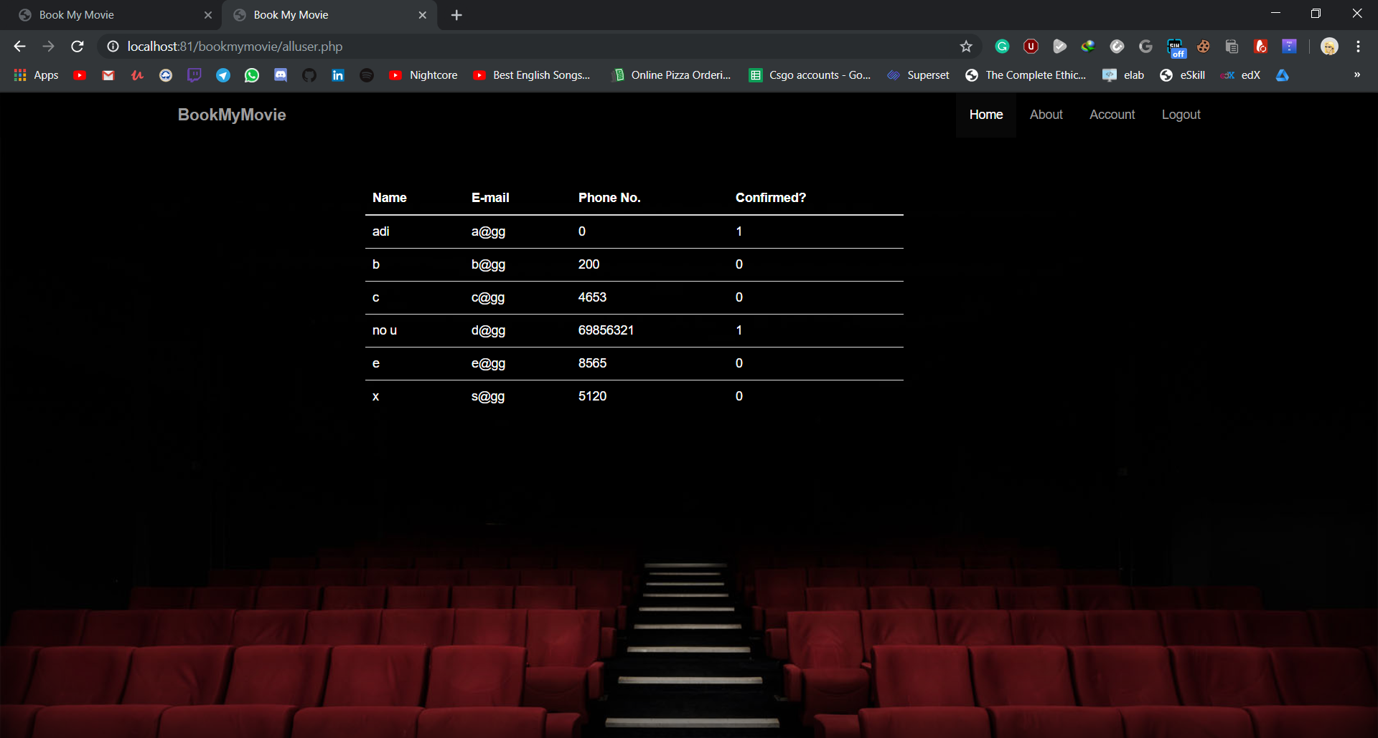

<?php

session_start();

if(isset($_SESSION['name']) && $_SESSION['name']=='admin@gg'){

include('includes/head.php');

include('includes/nav.php');

mysql_connect("localhost","root","");

mysql_select_db("bookmymovie");

?>

<div class="container cover">

<?php

$query="SELECT * FROM users";

$res=mysql_query($query);

$row= mysql_num_rows($res);

if($row!=0){

?>

<table class="table table-dark" id="up2">

<thead class="thead-dark">

<tr>

<th>Name</th>

<th>E-mail</th>

<th>Phone No.</th>

<th>Confirmed?</th>

</tr>

</thead>

<tbody>

<?php

while($row= mysql_fetch_array($res)){

echo '<tr>';

echo '<td>'.$row[0].'</td>';

echo '<td>'.$row[1].'</td>';

echo '<td>'.$row[4].'</td>';

echo '<td>'.$row[3].'</td>';

echo '</tr>';

}

?>

</tbody>

</table>

<?php

}

else{

echo '<div class="cover-text">No Users</div>';

}

?>

</div>

<?php

}

else if(isset($_SESSION['name'])){

header('location:index.php');

}

else{

header( "refresh:3;url=index.php" );

echo "<h2>Unauthorized Access</h2>";

echo "<h6>Redirecting in 5 seconds...</h6>";

}

include('includes/foot.php');

?>

**Log.php**

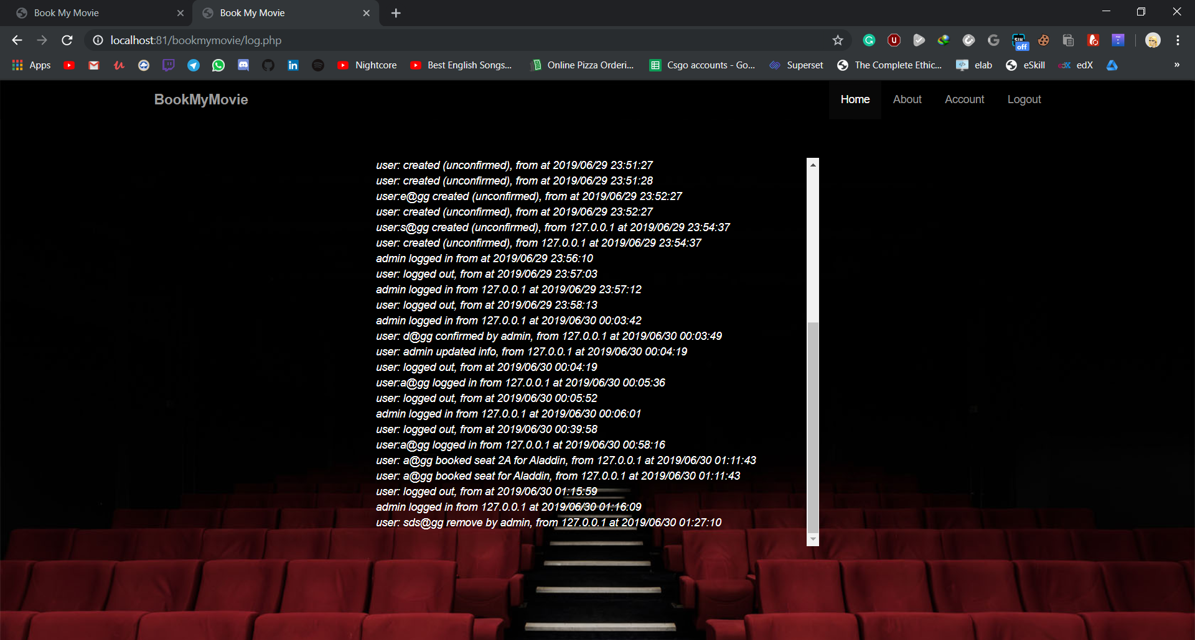

<?php

session_start();

if(isset($_SESSION['name']) && $_SESSION['name']=='admin@gg'){

include('includes/head.php');

include('includes/nav.php');

?>

<div class="container">

<div id="up3">

<em>

<?php while(!feof($log)) {

echo fgets($log) . "<br>";

}

?>

</em>

</div></div>

<?php

}

else{

header("location:index.php");

}

include('includes/foot.php');

?>

**Head.php**

<!doctype html>

<html>

<head>

<title>Book My Movie</title>

<link href="bootstrap/bootstrap.min.css" rel="stylesheet">

<link href="css/main.css" rel="stylesheet">

</head>

<body>

<?php

function getUserIpAddr(){

if(!empty($_SERVER['HTTP_CLIENT_IP'])){

$ip = $_SERVER['HTTP_CLIENT_IP'];

}elseif(!empty($_SERVER['HTTP_X_FORWARDED_FOR'])){

$ip = $_SERVER['HTTP_X_FORWARDED_FOR'];

}else{

$ip = $_SERVER['REMOTE_ADDR'];

}

return $ip;

}

$log= fopen('log.txt','a+');

date_default_timezone_set('Asia/Kolkata');

?>

**Nav.php**

<nav class="navbar navbar-fixed-top navbar-inverse">

<div class="container">

<div class="navbar-header">

<a class="navbar-brand" href="index.php">BookMyMovie</a>

</div>

<ul class="nav navbar-nav navbar-right">

<li class="active"><a href="index.php">Home</a></li>

<li><a href="about.php">About</a></li>

<li><a href="user.php">Account</a></li>

<li><a href="logout.php">Logout</a></li>

</ul>

</div>

</nav>

**Foot.php**

<script src="js/jquery-2.2.3.min.js"></script>

<script src="bootstrap/bootstrap.min.js"></script>

</body>

</html>

<?php

fwrite($log, $t);

fclose($log);

?>

**Style.css**

html{

background: url('img/show.png') no-repeat center center fixed;

background-size: cover;

}

body{

color: darkred;

}

.loginform{

text-align: center;

width: 30%;

margin: 0 auto;

margin-top: 30px;

}

legend{

font-size: 42px;

font-weight: 500;

}

label{

color: #6B0B07;

font-weight: 550;

font-size: 1.2em;

}

input{

height: 1.5em;

}

.button{

background-color: darkred;

padding: 5px;

width: 20%;

height: 40px;

color: white;

}

hr{

width: 70%;

}

a{

color: white;

text-decoration: none;

}

**Main.css**

nav.navbar-inverse {

background: rgba(0, 0, 0, 0.5);

border: none;

}

html,

body,

.cover {

height: 100%;

}

.tc {

text-align: center;

}

.navbar-header {

color: white;

font-size: 30px;

font-weight: 600;

}

body {

background: url('../img/banner.jpg') top left no-repeat;

background-size: cover;

}

.cover {

display: table;

width: 100%;

padding: 0 20%;

box-shadow: inset 0 0 100px #000;

}

.cover-text {

text-align: center;

color: white;

display: table-cell;

vertical-align: middle;

overflow: auto;

}

h5 {

color: white;

text-align: center;

margin: 0 auto;

padding-top: 50px;

}

#up {

padding: 100px;

margin-left: 450px;

width: 600px;

color: white;

}

#up2 {

margin: 100px;

width: 600px;

color: white;

}

#up3 {

margin: 100px;

margin-left: 25%;

width: 50%;

color: white;

height: 500px;

overflow: auto;

}

.form-actions {

text-align: center;

}

#movielist {

color: white;

text-align: center;

padding-top: 75px;

}

**Database**

**Bookmymovie**

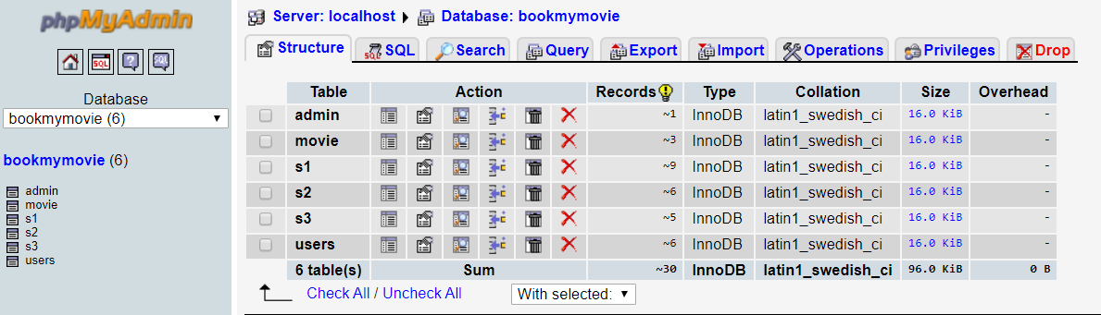

**admin**

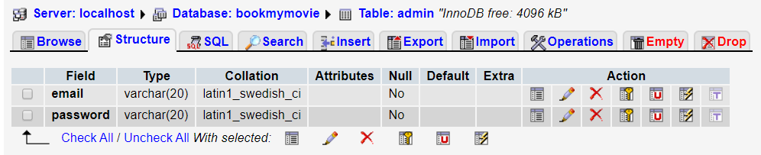

**users**

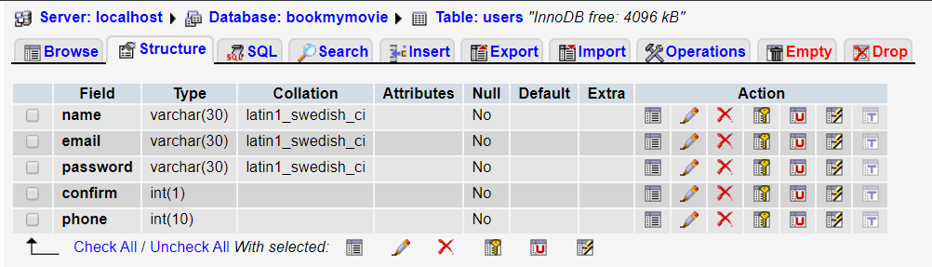

**s1**

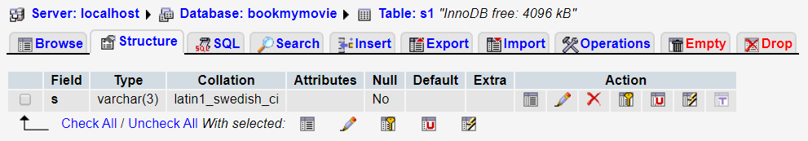

**s2**

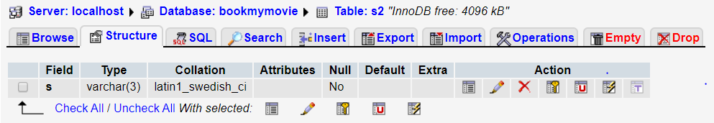

**s3**

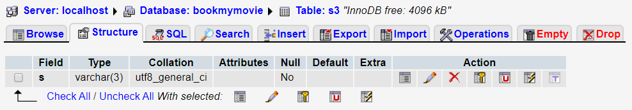

**movie**

